- 公园话题：A Garden
Describe a beautiful park or garden you visited.
You should say:
where it was
when you saw it
what you did there
and explain why you thought it was beautiful.
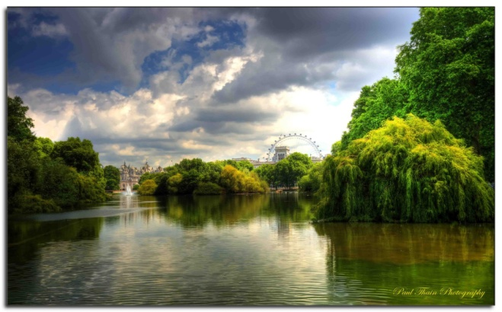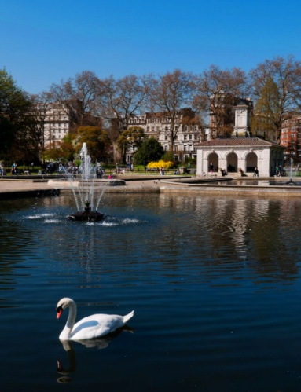
St.James Park Hyde Park
- 地理位置
St James's Park is at the heart of ceremonial London. It’s surrounded by some of the country's most famous landmarks including Buckingham Palace, Clarence House, St James's Palace and Westminster.
The park lies at the southernmost tip of the St James's area.
It’s located in the city center, just 10 mins drive to the railway station.
There’s a great location: 2 mins walk to Subway Line 10.
The Summer Palace, located northwest of Beijing’s center is mainly dominated by Longevity Hill and the Kunming Lake.
Hyde Park is open all year round and is readily accessible by public transport.
- 风景
Hyde Park is one of London's finest landscapes and covers 350 acre.
The park attracts a large number of wildfowl into the park, many of which are winter visitors to the park.
The lake is well-used by friendly ducks and other avian visitors and it is possible to select sitting places where all the surrounding buildings are obscured by trees.
Much of the wildlife in the park goes unnoticed by the majority of visitors. This includes a large number of 'minibeasts' such as beetles, bees…
The trees, shrub beds and herbaceous plantings provide rich habitats for song birds including the robins and…
Although the Park has foxes, wood mice and brown rats these are largely active at night and it is the grey squirrel is the most likely mammal for visitors to see.
St James's Park is a really great place to watch bats as dusk falls.
- 运动
Hyde Park was created to satisfy a royal passion for hunting. But over the years it became a place where people have pursued many other pleasures.
The lake is a lovely place to spend time in both winter and summer and there is always an activity going on there.
Over 7 million visitors visit Hyde Park each year. There's something for everyone in Hyde Park, from swimming and boating to concerts and exhibitions.
The paths and grass areas in Hyde Park are used extensively for walking, jogging and running.
- 个人感觉
I love St James's Park which is very handy if you are staying at Rubens Hotel.
The park is full of wildlife and I love watching the squirrels dashing up trees and eating!
Also, it is just big enough to stretch the legs or, more likely, to sit and relax away from the bustle of central London.
The floral displays are lovely, which create an amazing atmosphere.
Even though you will never get away from the noise of the cars, you at least do not have to look at them for a while!
What can I say? I enjoyed a quiet Sunday there, feeding the ducks , watching the kids sailing their paper boats…
HYDE PARK is a great example on how should the Park be, it’s a wide green area, you can walk, play with ducks, enjoy the sun in the sunny day.
If you find yourself at London in a sunny day, don't hesitate and go to take a walk there.
What a respite it is to be able to enjoy the out-of-doors in a place like Hyde Park.
For anyone coming to London, I'd encourage you to spend some time in a Hyde Park so you can get away from the traffic and buildings of the city.
some words:
classical-style
architectural
halls and pavilions
splendid sceneries
eye-catching
extraordinary
some words
picturesque
landscape
breath-taking nature
getaway,ideal place,natural beauty

- 房间话题 Your Home (Room)
Describe your favorite room in your house
You should say:
where is your house
how long you have lived there
what furniture your room has
and explain why you like it.
- 地理位置
It is located in a quiet neighborhood.
It’s located in the city center, just 10 mins drive to the railway station.
There’s a great location: 2 mins walk to Subway Line 10.
- 装修、装饰
It’s facing west so I can get a view of the sunset. My home is fairly spacious; lots of space and fairly white and bright and clean.
There is a big picture window overlooking the water that perfectly captures the rising sun. Lots of big windows opened to let the fresh salty sea winds blow into the house.
lots of posters into a picture frame to hang on a wall
As you come into my room, you can find the ______________in the center.
我喜欢那个大落地窗，透过它我可以看到美丽的景色. (french window, landscapes)
- 个人感觉
My room is a safe heaven. A place where I can snuggle(紧贴） under thick comforters, and read by candlelight. Where the light colors of the walls and ceiling calm me, while the vibrant colors of the bedding revive my worn spirits. It's a comfortable place.
A cozy heaven away from the noise, hustle & bustle of the outside world! It has luxurious green, cream & aubergine colors, I feel safe there & the colors make me feel creative.
It’s great to sip our tea or coffee and talk about our plans for the day every morning in the dining room.
I hate being in a dark cramped room with a low ceiling, I will be hyperventilating.
The blue walls make me think of the calming vast seas that relax me. The base boards and shutters are white which remind me of the pure white clouds in the sky. The white in my room helps me to have pure and clean thoughts.

